**NAME: CARMEL MAE R. LEQUIN**  **GR11- HE VALI**

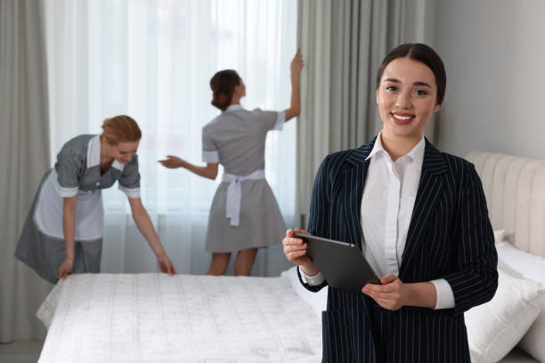

The woman in the foreground wearing a formal striped suit and holding a tablet is most likely the **Executive Housekeeper** or **Housekeeping Manager**. She is supervising, managing, and possibly inspecting the work being done. In the background, two housekeeping staff members (wearing uniforms) are cleaning the room one is making the bed, and the other is adjusting or checking the curtains.

The man on the right, dressed in a light-colored suit and holding what looks like a vacuum cleaner hose or a cleaning tool, appears to be the **Rooms Maintenance Supervisor**. He is instructing or demonstrating something to three hotel staff members (two women and one man), who are attentively observing and listening.



**Room boy, chambermaid or room attendant.**

A male housekeeper meticulously arranging bed linens to ensure guest comfort.​

**The Head Houseman** is responsible for maintaining cleanliness in guest rooms and **public areas**, assisting with luggage, and supporting housekeeping staff. A supervisor discussing cleaning protocols with staff in a hotel corridor.​

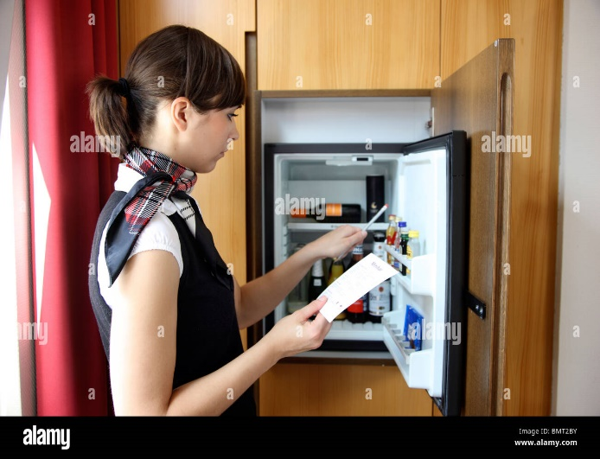

A **houseman** making a bed, ensuring guest rooms are prepared to standard.​

**MINI BAR RUNNER/ ATTENDANT**

A hotel staff member checking the mini bar inventory in a guest room.​

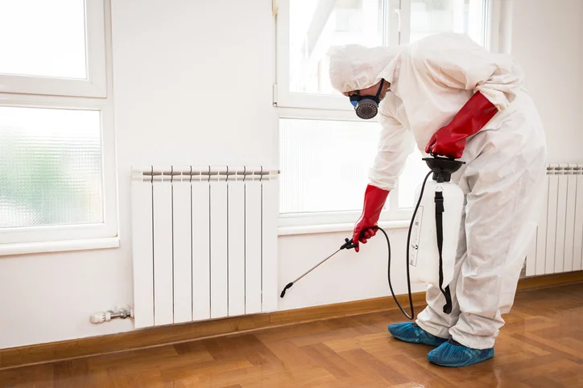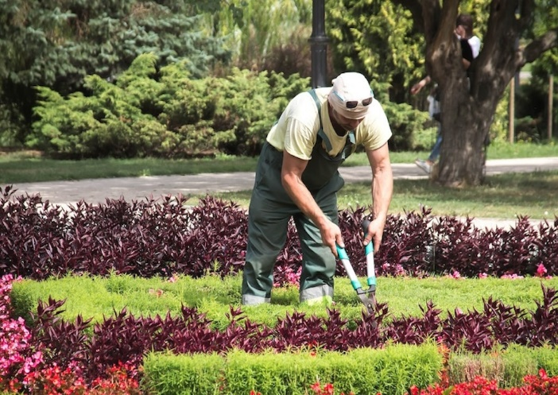

**PEST CONTROL TECHNICIAN**

Inspecting a property for signs of pest activity, like looking for droppings or damage.

**The gardener or grounds maintenance** worker is focusing on trimming or removing leaves, which is an important task for maintaining the health and appearance of a garden or lawn.

***NAME: CARMEL MAE LEQUIN***

***GR11- HE VALI***

***ESSAY***: **LEARNING ABOUT THE TOPIC**

Housekeeping is a fundamental aspect of managing any space, whether it's a home, hotel, or office. It involves maintaining cleanliness, order, and overall comfort for its occupants. Learning about housekeeping helps us to understand the essential role it plays in creating a pleasant and hygienic environment, as well as the skills and techniques required to carry out its duties effectively. Housekeeping is fundamental to managing any space, ensuring cleanliness, order, and comfort. Learning about it clarifies its crucial role in creating pleasant and hygienic environments.

The standards of ideal housekeeping are based on cleanliness, organization, and maintenance. It includes the thorough cleaning of all surfaces, rooms, and bathrooms, along with organizing belongings and ensuring that everything is in its proper place. Ideal housekeeping also involves regularly replacing linens and ensuring that all amenities are stocked and functional, contributing to a neat and comfortable atmosphere. Ideal housekeeping prioritizes cleanliness, organization, and maintenance, encompassing thorough cleaning and organization. Regular linen replacement and amenity restocking contribute to a comfortable atmosphere.

An essential aspect of housekeeping is its focus on maintenance. This involves ensuring that the facilities and equipment, such as lighting, plumbing, and appliances, are in working order. Regular checks and repairs prevent issues that could disrupt the comfort of the space and ensure that it remains safe for use. Maintenance in housekeeping focuses on ensuring facilities and equipment function correctly. Regular checks and repairs prevent disruptions and maintain safety.

In housekeeping, several key terminologies are used to describe specific tasks and processes. For instance, "turn down service" refers to preparing a room for the night, while "deep cleaning" involves a more thorough cleaning process beyond the usual tasks. Understanding these terms helps professionals communicate clearly and efficiently, ensuring that all tasks are performed to the highest standard. Housekeeping uses specific terminology to describe tasks and processes, such as "turn down service" and "deep cleaning". Understanding these terms ensures clear and efficient communication among professionals.

In conclusion, learning about housekeeping is essential to understanding its role in maintaining a clean and functional environment. By adhering to ideal standards and familiarizing oneself with common housekeeping terms, one can ensure the proper upkeep of any space, enhancing the comfort and satisfaction of those who use it. Learning about housekeeping is essential for maintaining clean and functional spaces. Adhering to standards and familiarizing oneself with terminology ensures proper upkeep and user satisfaction.